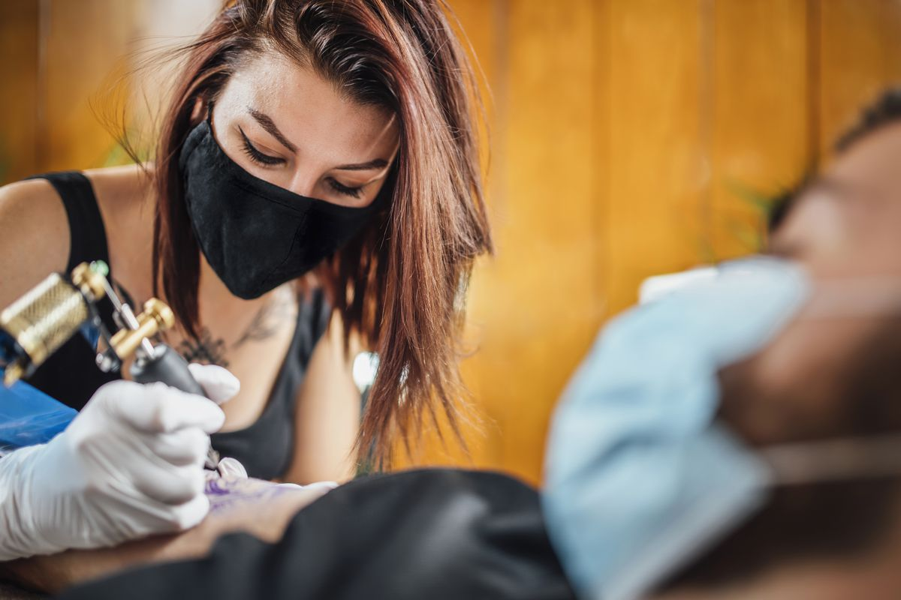
Title of Course:
TATTOOING
What comes to your mind when you hear the word tattoo? This depends on what opinion you have of it, do you consider tattooing as an art, a fashion, an aesthetics or some mark on the body that is worn by cultists, bikers, sailors and criminals?
A tattoo is a form of body modification made by inserting ink, dyes, and/or pigments, either indelible or temporary, into the dermis layer of the skin to form a design. The art of making tattoos is known as tattooing. - Wikipedia
Tattoo are worn for different reasons, as a symbol, for decoration or to picture someone or something.
The history of tattooing dates back in time all around the world, in the ancient Egypt for example, tattoo has been discovered in mummified human remains.
In the past tattooing is rarely considered an art, rather the human body is tattooed for cultural identity purpose (tribal marks especially), to showoff one’s position or status in the society, for treatment of sickness, as medicine, or for other spiritual purposes such as protection against spiritual attack.
In my early years, you can actually tell what tribe a person belongs to by looking at the person’s face, each child is tattooed on the face to show what tribe they belong, at times which home they are from and what position they occupy, the royal family especially takes pride in this.
At some point later, people began to abandon this act, mothers no longer want the tribal marks on their children’s face, and it became a thing of same to many who already had some mark, some were even looking for ways to have the marks or tattoo removed.

Tattooing has since evolved to being an art, a fashion used for beautification among others. It is now considered a profession where the tattoo artists makes a living from tattooing. In the past tattoos are normally permanent but now it can either be temporary or permanent and the tattooed has to make the choice, unlike in the past.
Take a good look around you today, you will see people all around wearing one form of tattoo or the other, especially in the entertainment industry, from the football pitch to the run ways, you will find them showing off their paintings, even on social media.
There are several reasons why people get tattoo on their skin, some of the reasons includes but not limited to the following;
- For cosmetic reasons, to cover up scars on the skin or to cover imperfection.
- In order to stand out and be noticed, to call attention to themselves
- To show off their personality
- As fashion to beautify their skin, add color to a part of their skin.
- For remembrance of something personal or dearly meaningful.
- To show affiliation or solidarity to a class or cult
- To show a change of lifestyle
- Addiction to pain
- For emotional reasons, e.g. tattooing the face or name of a lost loved one
- To enhance self-confidence and self esteem
- Cultural reasons
There are four main tools used for tattooing, the tattooing machine which looks more like a sewing machine. This electrically powered machine holds the needle that is used to piece into the dermis, which is the second layer of the skin. The skin is usually pieced thousands of times to achieve the desired result.
The Needles are the second tool used for tattooing and they come in different shapes and sized, depending on the use, either for outlining or for coloring
The third item is the inks and they come in various colors. The ink can get contaminated if not properly handled.
The fourth and most important tool is the Autoclaves. It serves as the sterilizer for other equipment.

Tattooing is one area of art that has come to stay and it is growing by the day, as more and more people are looking to get inked for several reasons. It is advised to take into consideration some facts before taking the step to get a tattoo done on your skin.
- You have to remember the pains that comes with the process of designing the art on your skin, is it a pain you are willing to stand?
- Most tattoos are permanent so you need to decide if that is a mark you intend to carry on your skin to your grave. There has been some instances where some people later in life have regrets about what they have inked into their skin and make several attempt to remove it.
- Some profession and religion in our society today frowns against the art of tattooing the body, depending on what your profession or religion is, you may want to either let it go or reconsider which part of your body you want to be inked.
- There are lots of tattoo artists that are not professionals and a mistake may have serious health implication, for this reason, you need to know where you get your tattoo done and with whom.

If eventually you decide to get inked, you would want to ensure the needles used for the tattooing are new needles, and in a sealed form and they are opened in your presence. Also ensure that the tools are well sterilized, the environment should also be as neat as possible and free from dirt. Not forgetting to do a background search of the tattooist who will be in charge putting the ink into your dermis.

Sources
https://en.wikipedia.org/wiki/Tattoo
https://www.karger.com/Article/Fulltext/369174
https://www.101corpuschristi.com/3169

